Contact Information
for pricing, samples, and orders:
Call Chris at: 518-779-9696
or
Email: Chris@kepamika.com

Please visit my website to see samples of my work:
http://Kepamika.com

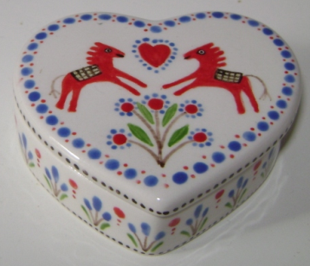
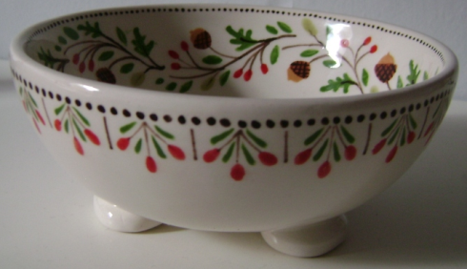
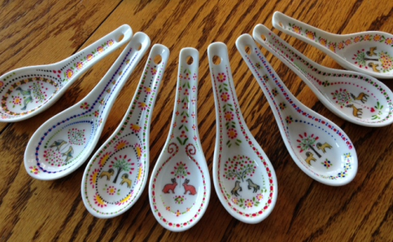
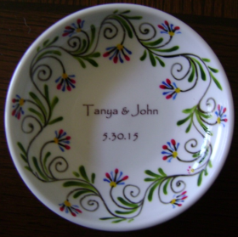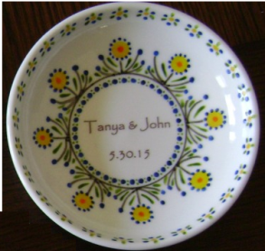

Elegant Wedding Favors
Specializing in unique, personalized favors

Custom Mementos for your special event:
Weddings
Anniversaries
Bar Mitzvahs
Bat Mitzvahs
Any Event!
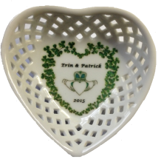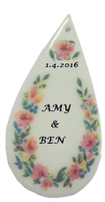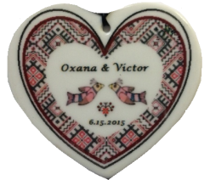
About Kepamika:
Kepamika is a small, home based business specializing in custom, one of a kind pieces. All art work is original and designed or hand painted by local artist, Christine Levy.

My small, home based business offers many advantages:
- Low overhead, savings are passed to customer
- No order is too small
- Work with you to get the design you love
- Provide sample favors before you order
- Completely customizable
- Mix and Match on orders

Delight your guests with a wedding memento that is also a beautiful work of art to be held for years to come.

Please ask for references! My many happy customers can tell you how easy and stress free the process was. I can also provide many sample pieces to help you decide.
Design and Sample: $40
I work with you to create a design (or designs) you love. Produce a sample of the actual end product. Create one alternate design and sample if the first one is not to your liking.

Or, if you prefer, provide me a price range and I can come up with several designs within your budget. I’ll provide one or two sample favors for you to choose from for a total order cost in your price range.

Prices are based on a per-piece price .

Order anywhere from 10 to 200 (or more) individual pieces. Your total order cost is the price of the item times the number of items ordered.

If items are to be shipped, the shipping costs will be extra. There are no handling charges, only the cost of shipping and packing materials

Example Wedding Favors:
1 inch heart pendant, both sides decorated $3.00
Mini Bonbon dish, 2” x 3” $4.50
Tiny gold handled dish, 2” x 2.5” $4.50

1 inch heart pendant
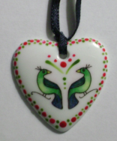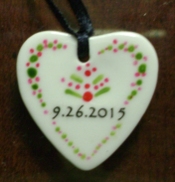

Mini Bonbon dish
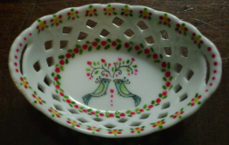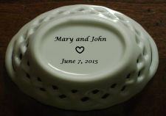

Tiny gold handled dish
